Name | SELECTION SORT
Type | Brute Force
Stable | NO (swaps)
In-place | YES
Time (Best) | O(n²)
Time (Average) | O(n²)
Time (Worst) | O(n²)
Input Sensitivity | None
Mechanism | Loop each value against every other value and swap. Always n²
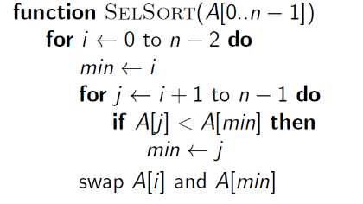
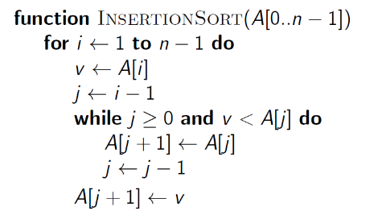
Name | INSERTION SORT
Type | Decrease & Conquer (1)
Stable | YES
In-place | YES
Time (Best) | O(n) (sorted)
Time (Average) | O(n²)
Time (Worst) | O(n²)
Input Sensitivity | Reverse-sorted is worst
Mechanism | Reverse back to correct position.  Check each value i with every value before i. If i smaller, move cursor(i) back, push compared value forward and repeat. Keep cursoring back until not smaller, instead of pushing forward, insert i. Iterate i.
n/a
Name | SHELL SORT
Type | Decrease & Conquer (1)
Stable | NO (skips)
In-place | YES
Time (Best) | O(n) (sorted)
Time (Average) | O(n^{1.5})
Time (Worst) | O(n²) (same as insertion)
Input Sensitivity | Reverse-sorted is worst
Mechanism | Insertion sort but in strides
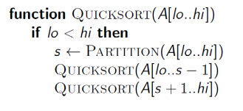
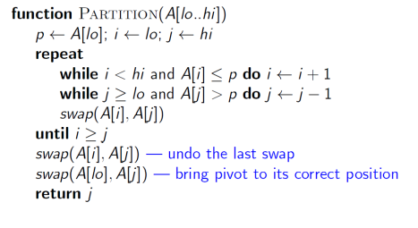
HOARE:
Name | QUICK SORT
Type | Decrease & Conquer (FACTOR)
Stable | NO (but can be made to be)
In-place | YES
Time (Best) | O(n)
Time (Average) | O(nlogn)
Time (Worst) | O(n²)
Input Sensitivity | Sorted speeds up
Mechanism | Can use Insertion Sort after pivoting.  Should start with initial median pivot (sorted median of 3) is better than random pivot.
Name | MERGE SORT
Type | Decrease & Conquer (FACTOR)
Stable | YES
In-place | NO (additional arrays)
Time (Best) | O(nlogn)
Time (Average) | O(nlogn)
Time (Worst) | O(nlogn)
Input Sensitivity | NONE (always nlogn)
Mechanism | Mergesort separates into individual arrays  Merge step re-joins in sorted order.
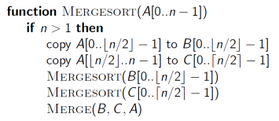
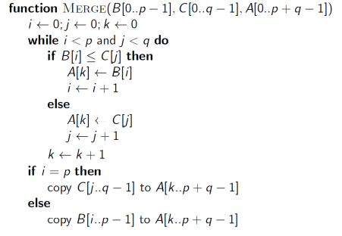

Name | HEAP SORT
Type | Transform & Conquer
Stable | NO
In-place | YES
Time (Best) | O(nlogn)
Time (Average) | O(nlogn)
Time (Worst) | O(nlogn)
Input Sensitivity | NONE (always nlogn)
Mechanism | Build heap + remove max

